M 080
MODEL PAPER
B.E. DEGREE EXAMINATION.
Second Semester
Aeronautical Engineering
IT 132 — ELECTRICAL ENGINEERING
(Common to Automobile Engineering/Production Engineering)
Time : Three hours Maximum : 100 marks
Answer ALL questions.
PART A — (10 × 2 = 20 marks)
- State Thevenin's and Norton's theorem.
- Find the equivalent resistance between the terminals ‘a’ and ‘b’ in the resistive network shown in Fig. 2.
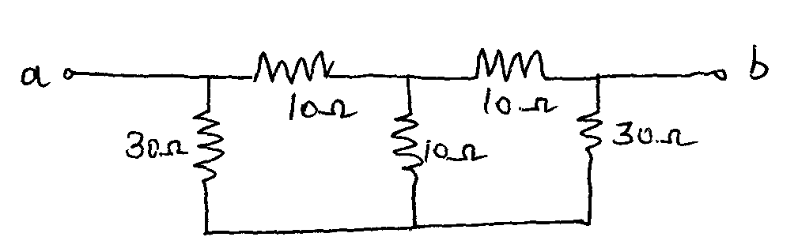
Fig. 2
- Give atleast four comparisons between electric and magnetic circuits.
- Tow long parallel conductors lies in air at 0.5 m apart from each other and carries a current of 2 amps each in the same direction. What is the magnitude and direction of force experienced by both conductors?
- Find the form factor of the periodic waveform shown in Fig. (5).
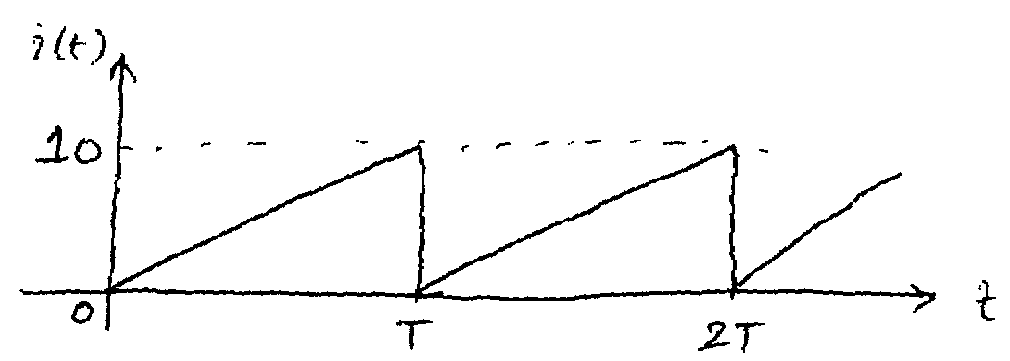
Fig. 5
- A series RLC circuit has Q–factor of 75 and bandwidth of 160 Hz. Calculate the resonant frequency and lower and upper half power frequencies.
- What is back emf in a d.c. motor? What is its significance?
- State the necessary conditions for voltage build–up in a dc shunt generator.
- A 230/460 V transformer has a primary resistance of 0.2 Ω and reactance of
0.5 Ω and corresponding values for secondary are 0.75 Ω and 1.8 Ω respectively. Find the secondary terminal voltage when supplying 10 A to load at 0.8 pf lagging.
- Mention atleast three characteristic features of synchronous motor.
PART B — (5 × 16 = 80 marks)
- (i) State and explain Kirchoff's circuital laws. (4)
(ii) Determine the magnitude and direction of current in the detector (galvanometer) whose resistance is 10 Ω in the bridge circuit shown in
fig (11. ii) using mesh current analysis. (12)
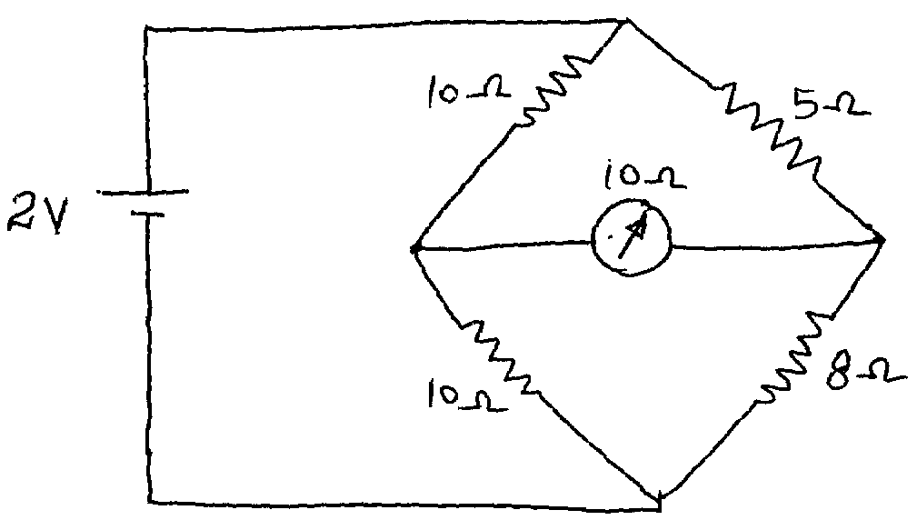
Fig. (11. ii)
- (a) (i) Explain the term leakage flux and fringing in magnetic circuits. (4)
(ii) The rectangular magnetic core shown in Fig. 12 (a. ii) has an air
gap cut across one of its limbs. Find the exciting current needed to
create an air gap flux of 2 mWb. The relative permeability of the
core is 4000. (12)
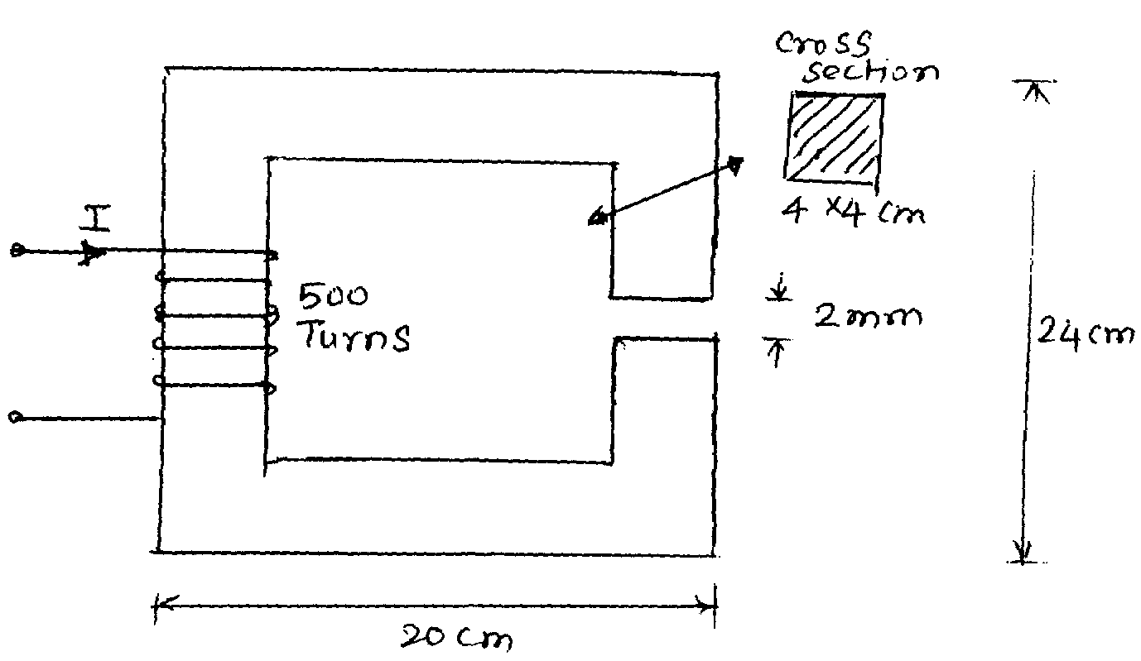
Fig 12 (a. ii)
Or
(b) (i) A coils having a self inductance of 120 μH is connected in series
with a second coil having a self inductance of 180 μΗ and the
combination is found to have an effective inductance of
140 μΗ. Calculate (1) mutual inductance, (2) the coefficient of
coupling (3) effective inductance of the series combination if
terminals of one of the coils are interchanged. (8)
(ii) Derive an expression for lifting power of a magnet. (8)
- (a) (i) A resistor of 120 Ω is connected in series with a 60 μF capacitor
across a 240 V, 50 Hz supply. Find (1) Impedance, (2) The current
(3) Power factor (4) Phase angle (5) Voltage across the resistor and
capacitor. Draw the phasor diagram. (8)
(ii) In a RLC series circuit, if $w_{1}$ and $w_{2}$ are half power frequencies
d if $w_{r}$ is the resonant frequency prove that $w_{r}^{2}=w_{1} w_{2}$. (8)
Or
(b) (i) A balanced star–connected load of $(8+j 6) Ω$ per phase is connected
to a three phase, 230 V supply. Find (1) line current (2) power factor
(3) active power (4) reactive power and (5) total volt ampere. (6)
(ii) Derive an expression for wattmeter readings and power factor for
three phase power measurement by two wattmeter method. (10)
- (a) (i) Derive an expression for e.m.f. developed in a d.c. generator. (8)
(ii) A d.c. shunt generator delivers 195 Amps at a terminal voltage of
250 V. The armature resistance and shunt filed resistance ae 0.2 Ω
and 50 Ω respectively. The iron and friction losses equal 950 W.
Find (1) emf generated (2) Cu. losses (3) Input power and
(4) efficiency. (8)
Or
(b) (i) Describe the different characteristics of a d.c. shunt and series
motors with graphs. (10)
(ii) A dc shunt motor runs at 900 rpm from a 460 V supply when
taking an armature current of 25 A. Calculate the speed at which it
will run from a 230 V supply when taking an armature current of
15 A. The resistance of the armature circuit is 0.8 Ω. Assume the
flux per pole at 230 V to have decreased to 75% of its value
at 460 V. (6)
- (a) (i) Explain with diagrams how a transformer works under load
condition. (8)
(ii) A 50 Hz, 8 pole induction motor has a full–load slip of 4%. The rotor
resistance is 0.001 Ω/phase and the standstill reactance is
0.005 Ω/phase. Find the ratio of maximum to full load torque and
the speed at which the maximum torque occurs. (8)
Or
(b) (i) Calculate the speed and open circuit line and phase voltages of
a 4 pole, 3 phase, 50 Hz star connected alternator with 36 slots and
30 conductors per slot. The flux per pole is 0.05 Wb sinusoidally
distributed. (10)
(ii) Write a short note on V–curves of a synchronous motor. (6)
—————

